Abdurrahman Qureshi

210451

EXP18

-----------------------------------------------------------

**1)Code:**

#include<iostream.h>

#include<conio.h>

void swap(int,int);

void swap(char,char);

void swap(float,float);

void main()

{

int a,b;

float c,d;

char c1,c2;

clrscr();

cout<<"Enter two integer numbers to

swap:\t";

cin>>a>>b;

cout<<"Enter two float numbers to

swap:\t";

cin>>c>>d;

cout<<"Enter two characters two swap:\t";

cin>>c1>>c2;

swap(a,b);

swap(c,d);

swap(c1,c2);

getch();

}

void swap(int a, int b)

{

int t;

cout<<"\nBefore swapping int numbers

are:\n ";

cout<<a<<"\t"<<b<<"\n";

t=a;

a=b;

b=t;

cout<<"After swapping int numbers are:\n

";

cout<<a<<"\t"<<b<<"\n";

}

void swap(float c,float d)

{

float t;

cout<<"\nBefore swapping float numbers

are:\n ";

cout<<c<<"\t"<<d<<"\n";

t=c;

c=d;

d=t;

cout<<"After swapping int numbers are:\n

";

cout<<c<<"\t"<<d<<"\n";

}

void swap(char c1,char c2)

{

char t;

cout<<"\nBefore swapping characters

are:\n ";

cout<<c1<<"\t"<<c2<<"\n";

t=c1;

c1=c2;

c2=t;

cout<<"After swapping int numbers are:\n

";

cout<<c1<<"\t"<<c2<<"\n";

}

**Output:**

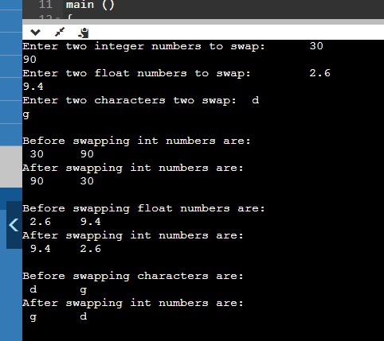

**2)Code:**

#include<iostream.h>

#include<math.h>

#include<conio.h>

float distance(float,float,float,float);

float

distance(float,float,float,float,float,float);

void main()

{

clrscr();

float x1; float x2;

float y1; float y2;

float distance_1;

cout<<"\n *** 2D Distance

****"<<endl;

cout<<"\n Enter the value of the first

point P1 :"<<endl;

cout<<"\t\t x_1 = "; cin>>x1;

cout<<"\t\t y_1 = "; cin>>y1;

cout<<"\n Enter the value of the

second point P2 :"<<endl;

cout<<"\t\t x_2 = "; cin>>x2;

cout<<"\t\t y_2 = ";cin>>y2;

float x_1; float x_2;

float y_1; float y_2;

float z_1; float z_2;

float distance_2;

cout<<"\n\n *** 3D Distance

****"<<endl;

cout<<"\n Enter the value of the first

point P1 :"<<endl;

cout<<"\t\t x_1 = "; cin>>x_1;

cout<<"\t\t y_1 = "; cin>>y_1;

cout<<"\t\t z_1 = "; cin>>z_1;

cout<<"\n Enter the value of the

second point P2 :"<<endl;

cout<<"\t\t x_2 = "; cin>>x_2;

cout<<"\t\t y_2 = "; cin>>y_2;

cout<<"\t\t z_2 = "; cin>>z_2;

getch();

clrscr();

cout<<"\n *** 2D Distance

****"<<endl;

cout<<"\n The values of the points P1

& P2 are :"<<endl;

cout<<"\t\tP1 (x1,y1) = P1

("<<x1<<","<<y1<<")"<<endl;

cout<<"\t\t P2 (x2,y2) = P2

("<<x2<<","<<y2<<")"<<endl;

cout<<"\n Distance b/w P1 & P2

is :"<<endl;

distance_1=distance(x1,y1,x2,y2);

cout<<"\t\t ³P1P2³ =

"<<distance_1<<endl;

cout<<"\n\n *** 3D Distance

****"<<endl;

cout<<"\n The values of the points P1

& P2 are :"<<endl;

cout<<"\t\t P1 (x1,y1,z1) = P1

("<<x_1<<","<<y_1<<","<<z_1<<")"<<endl;

cout<<"\t\t P2 (x2,y2,z2) = P2

("<<x_2<<","<<y_2<<","<<z_2<<")"<<endl;

cout<<"\n Distance between P1 & P2

is :"<<endl;

distance_2=distance(x_1,y_1,z_1,x_2,y_2,z_2);

cout<<"\t\t ³P1P2³ =

"<<distance_2<<endl;

getch();

}

float distance(float x_1,float y_1,float

x_2,float y_2)

{

float distance=0;

distance=sqrt(pow((x_2-

x_1),2)+pow((y_2-y_1),2));

return distance;

}

float distance(float x_1,float y_1,float

z_1,float x_2,float y_2,float z_2)

{

float distance=0;

distance=sqrt(pow((x_2-

x_1),2)+pow((y_2-y_1),2)+pow((z_2-z_1),2));

return distance;

}

**Output:**

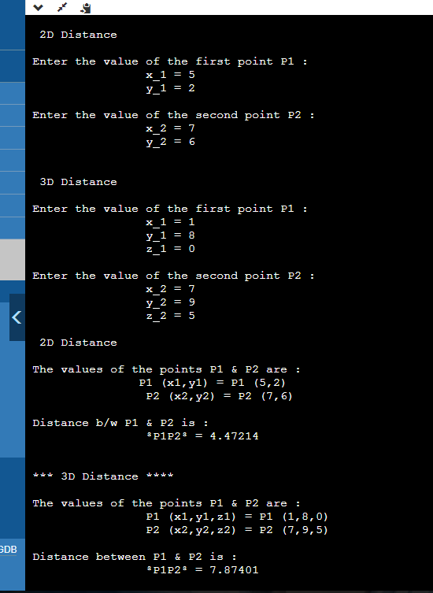

1. **Code:**

#include<iostream.h>

#include<conio.h>

void area(int,int);

void area(int);

void area(float,float);

void area(float);

void main()

{

clrscr();

int a,b;

int f;

float c,d;

float r;

cout<<"\nEnter side of square: ";

cin>>f;

area(f);

cout<<"\nEnter radius of circle: ";

cin>>r;

area(r);

cout<<"\nEnter length and breadth of

rectangle: ";

cin>>a>>b;

area(a,b);

cout<<"\nEnter base and height of triangle: ";

cin>>c>>d;

area(c,d);

getch();

}

void area(int l,int b)

{

cout<<"Area of rectangle="<<l*b<<endl;

}

void area(float b,float h)

{

cout<<"Area of triangle="<<h*b<<endl;

}

void area(float r)

{

cout<<"Area of circle="<<3.14*r*r<<endl;

}

void area(int s)

{

cout<<"Area of square="<<s*s<<endl;

}

**Output:**

